BTS-(R/S)fi(SF1 1.1 8-1e01 Reg. No.
B.Tech. Degree I Semester Regular and Supplementary/ II Semester Sapplementary Examinution November 2018
CS/EC/IT AS 15 -1102 B & CE/EE/}IB/SE AS 1'1202 A ENGII{'EE,RING CHEMISTRY (2015 Scheme)
_{Time: 3 Hours} Maximum Marks : 60 PART A
(Answer ALL questions)
I. (a) Explain why (i) Sodium chloride crystal is hard but brittle. (ii) Graphite is a conductor of electricity but diamond is a non-conductor.
₍₁₀ x2:20)
(b)
Give the thermodynamics of adsorption.
TMS is used as internal reference in NMR. Why?
(c)
Derive Nemst equation for single electrode potential.
(d)
ff 5A% of a gas decomposed in second order way in 40 minutes, what
(e)
would be the time taken for 75Yo of the gas to decompose?
(0
Give the different statements of second law of thermodynamics. Define the terms (i) Chemical potential (ii) fugacity.
(e)
State and explain Troutons rule. Give two exceptions to this rule with
(h)
reason.
What are condensation polymerization and co-polymerization? Give one
(i)
example for each.
6) Explain (i) aniline point (ii) viscosity index indicating their industrial importance.
PART ^{B}(4"
II. (a) What are point defects? Explain two stoichiometric and two non stoichiometric defects in crystals with examples.
(b) The rotational spacing of (cN) in the *i.ro*ur* spectrum is 3.82 Cu-l. Calculate the bond length. (C:12 N=14)
(c) How is BET adsorption isotherm used to determine the surface area of a solid catalyst?
OR
_{l0} :40) (4)
(3)
(3)
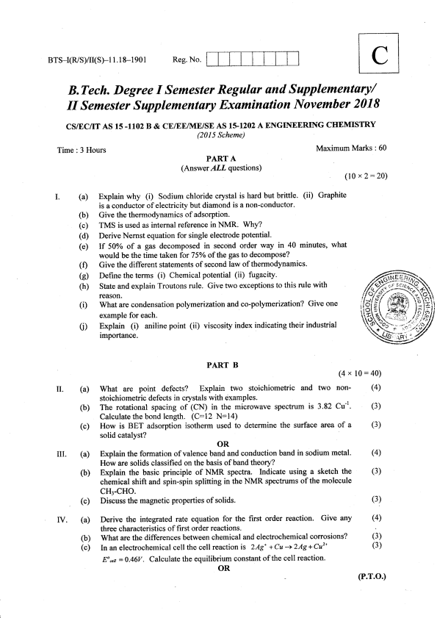
(a) Explain the formation of valence band and conduction band in sodium metal.
m.
How are solids classified on the basis of band theoty?
(b) Explain the basic principle of NMR spectra. Indicate using a sketch the chemical shift and spin-spin splitting in the NMR spectrums of the molecule cH3-cHo.
(c) Discuss the magnetic properties of solids.
(a) Derive the integrated rate equation for the first order reaction. Give any
rv.
three characteristics of fi rst order reactions.
(b) What are the differences between chemical and electrochemical corrosions? (c) In an electrochemical cell the cell reaction is ZAgt + Cu -+ 2Ag + Cuz* Eo xn = 0.46V . calculate the equilibrium constant of the cell reaction. OR
(4)
(3)
(3)
(4)
(3)
(3)
(P"r.o.)
v. _{{a)}
(b)
(c)
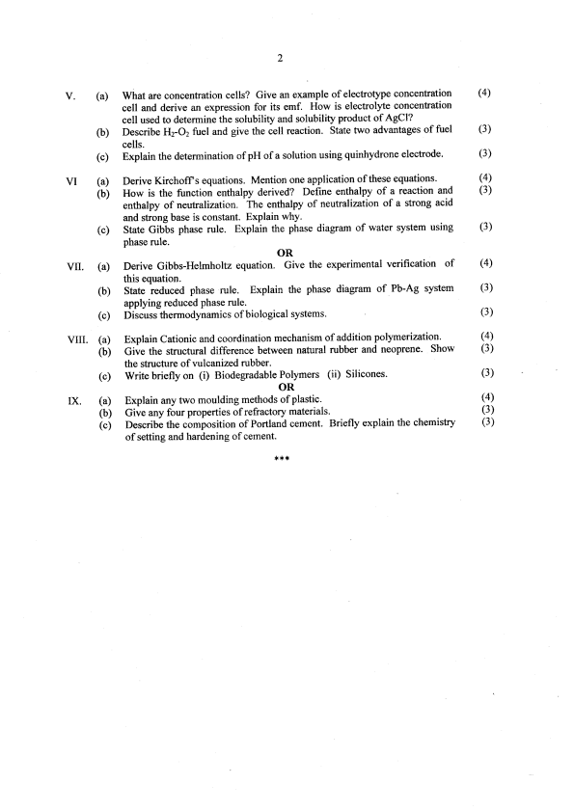
2
(4)
What are concentration cells? Give an example of electrotype concentration cell and derive an expression for its emf. How is electrolyte concentation cell used to determine the solubility and solubility product of AgCl? (3)
Describe Hz-Oz fuel and give the cell reaction. State two advantages of fuel cells.
(3)
Explain the determination of pH of a solution using quinhydrone electrode.
u (a) (b)
(c)
Derive Kirchoff s equations. Mention one application of these equations. (1) How is the function enthalpy derived? Define enthalpy of a reaction and (3) enthalpy of neutralization. The enthalpy of neutralization of a strong acid and strong base is constant. Explain why.
State Gibbs phase rule. Explain the phase diagram of water system using (3) phase rule.
VII. (a)
OR
Derive Gibbs-Helmholtz equation. Give this equation.
the experimental verification of (4)
State reduced phase rule. Explain the phase diagram of Pb-Ag system
(3)
(b)
applying reduced phase rule.
(3)
Diseuss thermodynamics of biological systems
(c)
vm. (a) (b)
Explain Cationic and coordination mechanism of addition polymerization. (4) Give the sffuctural difference between natural rubber and neoprene. Show (3) the structure of rulcanized rubber.
(c)
Ix. (a) (b)
(c)
Write briefly on (i) Biodegradable Polymers (ii) Silicones. OR
Explain any two moulding methods of plastic.
Give any four properties of refractory materials'
Describe the composition of Portland cement' Briefly explain the of seffing and hardening of cement.
***
(3)
(4)
(3)
chemistry (3)

